Twister Part 2

Coordinates and Shape animation!

## If you missed last week, don’t worry you can download the code from the Coder Dojo athenry website.

Last week we built a custom block that can be used to draw shapes with any number of sides. This week we will expand on that and play with our block in all sorts of ways.

The code we ended up with last week is below:

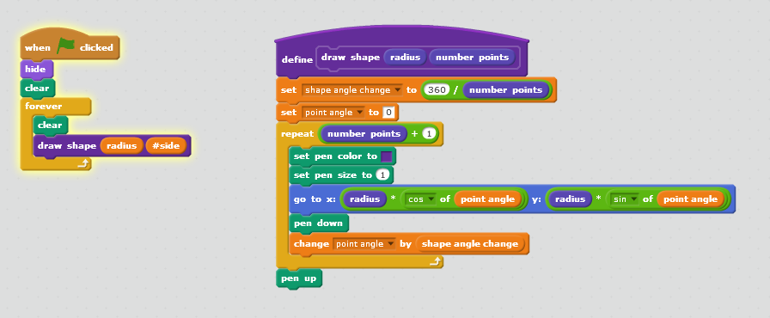

Do you remember what Sin and Cos do?

## Toggling the Controls

It’s nice having the controls, but we also want to look at our shapes without distraction. How about we add in a control to show and hide the variables?

Let’s use the letter V for this!

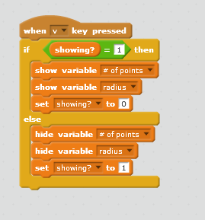

Now, when you press V, the controls will show or hide. Keep this up to date as we add more variables.

Every time we add a variable, we can add it to the controls!

## Exercise: Let’s add some code to change the background!

Add a fully black background, this will look neat.

You can add other backgrounds if you like. How about some stars?

Set it so that pressing B toggles between the backgrounds!

## Moving our shape!

The shape looks good, but will be better if it’s moving.

1. Add a new input the block – the “start angle”

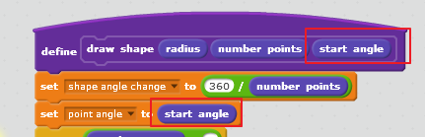

Notice that if you set different start angles, the shape is drawn from a different place?

If we change the start angle, it should look like it’s rotating. Let’s try!

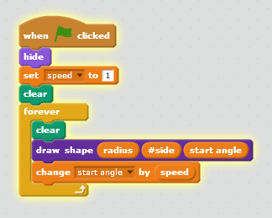

This way works, but the angle will be getting bigger forever.. Not really a problem but not harm in setting it back to 0 when it’s bigger than 360:

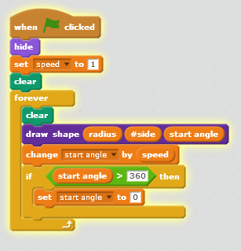

1. Lets add some stars at the points! That can look cool!!

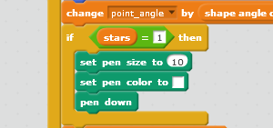

## How about 3D??

The word “2D” means two dimensional. Scratch like all computer programs are two dimensional.. but we can do some stuff that tricks out brain into thinking it looks a bit like a shape with depth.

Remember our shape is based on a circle like a plate or a coin.

What does a coin look like if you rotate it?



Rotating a circle around the x-axis “squashes” it into something called an “ellipse”

(note: it actually makes a shape a bit different than an ellipse due to something called perspective, but we won’t bother with that today, maybe next week in a new project!)

To make our shape look like an ellipse we reduce the “Y” value.

Let’s try it!

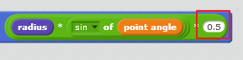

This works, and makes it look flat like below:

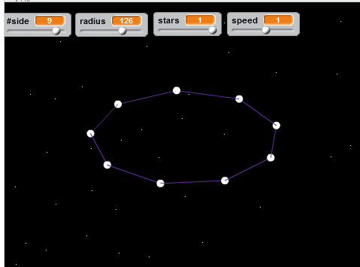

Instead of a fixed number, it’s even better if we think about the angle that someone is looking at the shape.

We can imagine someone looking at a disk. The angle between their eyes and the shape is called the viewing angle.

In fact, the amount you squash it by is the Sin of the viewing angle. I’ll draw this out on the board to explain it!

Let’s add a viewing angle and see what it looks like!

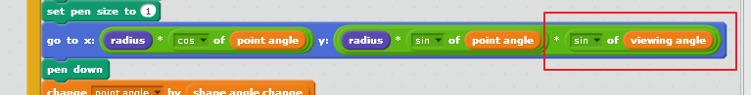

Nice! Now we can change the angle that we look at the shape

## More than one Shape

We now have a block that can draw rotating shapes at any angle.

How about we draw more than one?

Two triangles on top of one another can look like a star – let’s try out drawing a star!

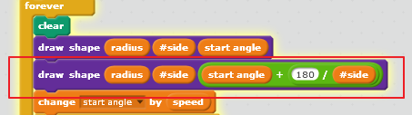

The second shape starts at a different angle to the first one.

This makes it look like a star – cool!

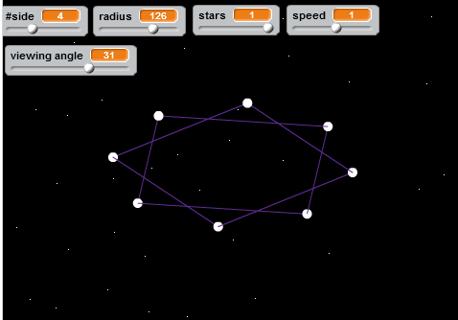

## Putting a gap between the shapes

Shapes on top of one another is nice, but how about the ability to space them out at different heights – this would look really 3D.

To Space them out the first step is to introduce a new variable to the custom block “start Y”.

This is the point to start working out the Y coordinates – because we don’t have any, they are all started at 0. We just add start Y to the Y point.

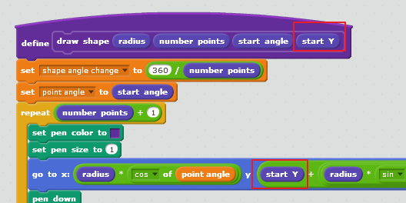

Your two shapes can now be spaced out:

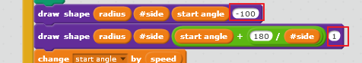

This looks awesome, but the shapes kind of move apart when you look at them from a high viewing angle. The way out of this is to multiple the “start Y” by the Cos of the viewing Angle. By doing this when the viewing angle is 0, the Start Y * Cos(Viewing Angle) will be Start Y. When the viewing angle is 90, the shapes will move together as the start Y will be multiplied by 0.

Mark will sketch this out on the board – anyhow it doesn’t matter if you don’t quite get it, the formula is below for Y:

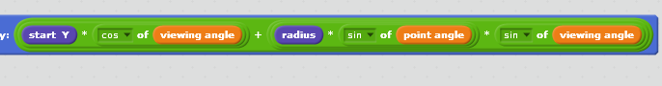

## Putting it all together in a full Twister!!

We are going to use our block to make a full Space structure with control panel.

Add three new variables

**#shapes**: the number of shapes in the structure

**Gap**: the space between each shape

**Twist**: the angle between the shapes

Make them hide and show like the other variables.

The full final listing is below! Well done if you made it this far!!!

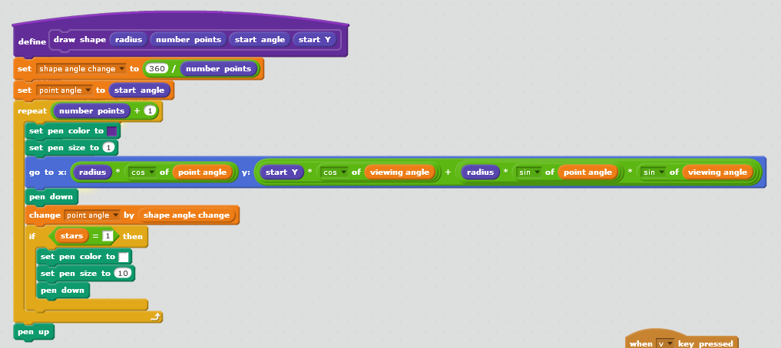

The shape block

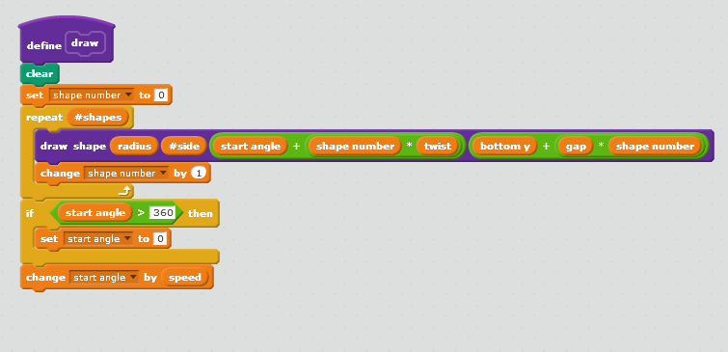

A draw block – this is done as another custom block to avoid the screen flicker (make sure scree refresh disabled)

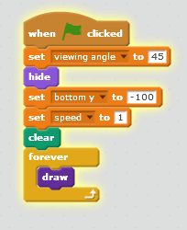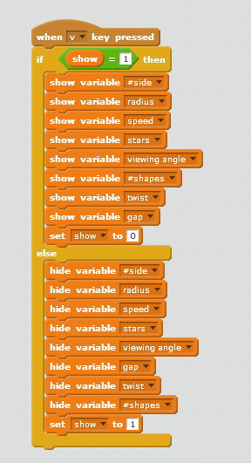

The main code and code to hide the variables

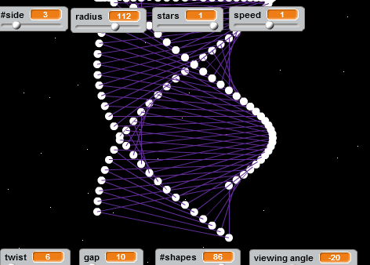

# Some ideas based on this!

* Can you make it so that the speed and the viewing angle are controlled by the mouse?
* Can you make it for that + and – will “zoom” in and out?
* Can you set up a “shrink” variable that will make each shape a bit smaller than the one on top? This can be used to make cool shapes and funnels!
* Can you add variables to control the colors?
* Can you copy this and make a 3D Christmas tree (hint thick green lines, flashing lights, shapes gradually reducing in size)

A lot of these things and more are in the version of the code that is available for download this week!